COLORADO & RECYCLING
Did you know that Colorado falls way behind most other states when it comes to recycling? Colorado Springs is one of the top tourist destinations in the nation, known for our beautiful mountains and healthy lifestyles. Despite our love of open trails and spaces, our community fails to rise to the occasion when it comes to reducing our carbon footprint through basic recycling.
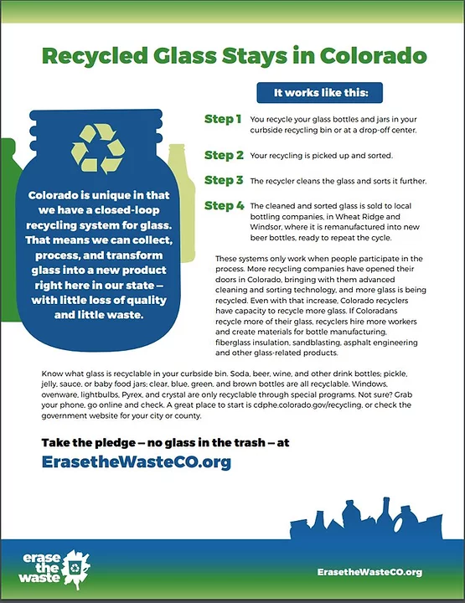
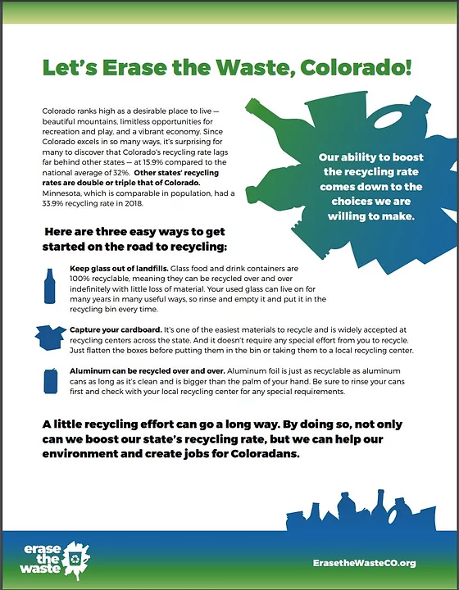
Colorado has now created the Erase the Waste statewide education campaign on recycling. Visit https://www.erasethewasteco.com/ to learn more! Click to Download and share the Erase the Waste PDF to tell your friends and neighbors how easy it is to recycle in Colorado.

